Delete all inactive relevant records

Records can be marked as inactive from the relevant record landing page from Pega 8.1. Prior to that user could mark a record as inactive by clicking on the bin (delete) icon. In Pega 8.1 to bring more clarity in the relevant record landing page, there is option to view all the inactive relevant records. This would give a clear picture to the application developer about which records are marked as relevant and which are marked as inactive. When a record is marked as relevant on a top-level class and that is marked as inactive in an inherited class, that record won’t be available as relevant for that inherited class.
During development, the application developer might go for multiple iterations of marking records as relevant and marking them as inactive. This process adds a lot of unwanted inactive records. It would always make more sense to have only those record as inactive which we don’t want as relevant in the current class. From platform we don’t have any option to delete or remove these inactive records. This component contains an API (Activity) DeleteAllInactiveRelevantRecordsForAClass which would do this with ease.
This API is mainly designed for Pega 8.1 and above version, but it would work on Pega version lower than 8.1 as well. But user can’t see its affect at the relevant record landing page in Pega versions lower than 8.1. However, the affect can be seen at the design time in App studio.

How to use DeleteAllInactiveRelevantRecordsForAClass
To use this Activity, you can call it from any of UI elements action or you can run it independently through Actions -> Run. This activity takes the following parameter.
ContextClass: In the ContextClass Name parameter provide the class of a case type or data type for which you want to delete all the inactive records.
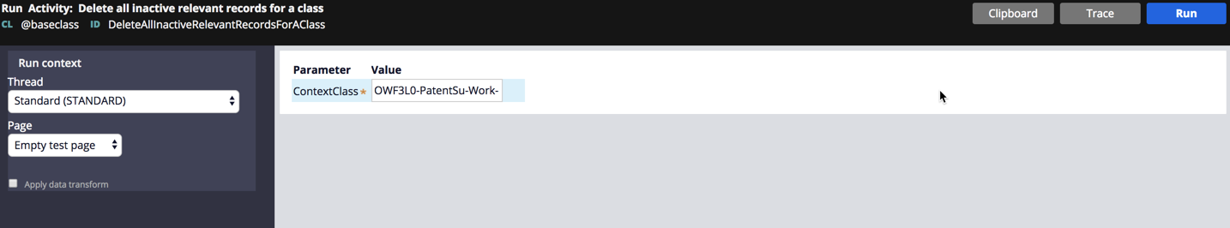
Once the activity is run successfully you will see the below message.
Apart from running this activity directly you can call it from action of any of the UI element. While calling this Activity, you need to pass the ContextClass (explained above) as a parameter.
You can verify at the landing page to see if all the inactive are deleted or not. You should see a before and after running the activity, screenshot of the landing page for reference below.
Before running the Activity:
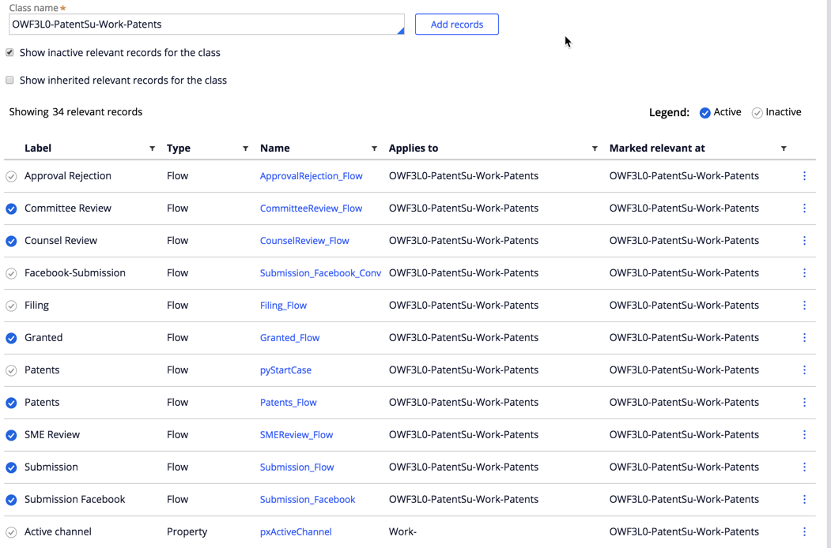

After running the activity:
